- Angle Properties of Circles
1. In the figure below PQR and S are points on the circumference of a circle centre O. The point TSO and Q lie on a straight line MPT is a tangent to the circle at P.
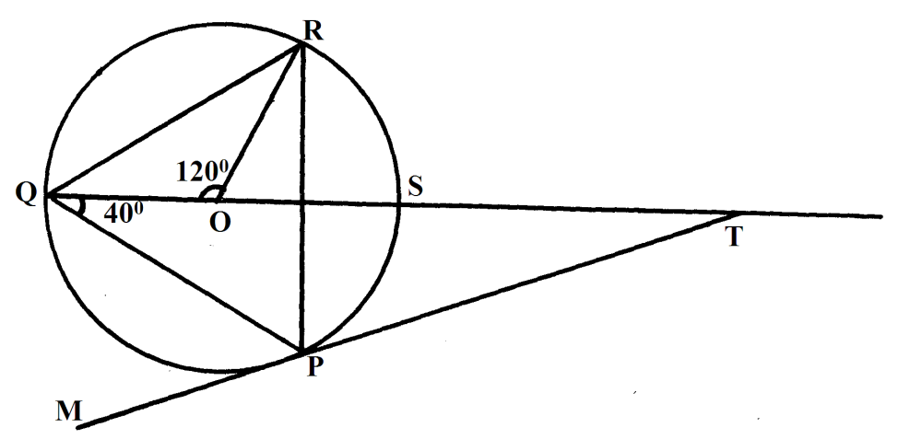
Find the values of the following angles stating reasons in each case.
(a) ∠SRP (2mks)
(b) ∠ORP (2mks)
(c) ∠RPT (2mks)
(d) ∠STP (2mks)
(e) ∠QPM (2mks)
2. In the figure below, TA is a tangent to the circle ABCD with centre O. 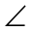TAD = 48⁰ and BOD = 116⁰
116⁰
48⁰
26⁰
O
A
B
C
D
T

Giving reasons calculate:
  - ACD (2mks)
  - ABO (2mks)
  - ADO (2mks)
  - ACB (2mks)
  - ATB (2mks)
3. In the figure below AB = 8cm and O is the centre of the circle. Determine the area of the circle if ∠OAB = 15º (3mks)
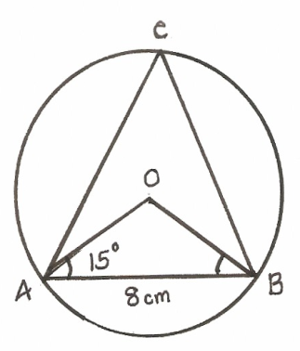
4.
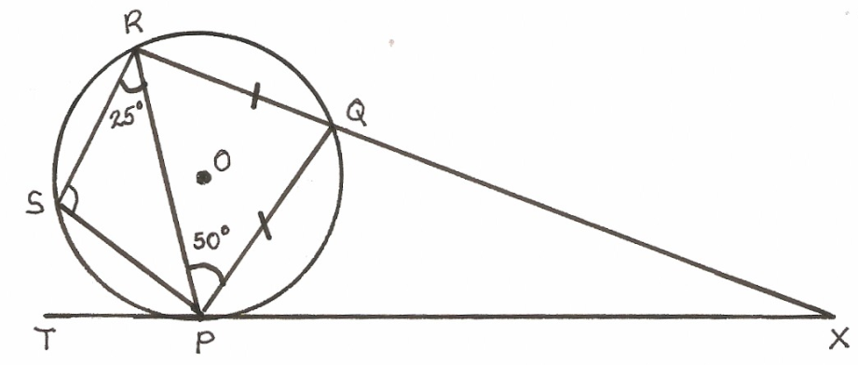
The figure above is a cyclic quadrilateral PQRS. Given that TPX is a tangent at P and O is the centre of the circle and that RQX is a straight line with ∠RPQ = 50º and ∠PRS = 25º, giving reason in each case find:
(a) angle PRQ (2mks)
(b) angle PSR (2mks)
(c) angle PXQ (2mks)
(d) angle TPS (2mks)
(e) angle POS (2mks)
5. In the figure below ABCD is a circle with centre O. AB and DC meet at a point E outside the circle. DC = BC and 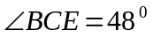
48⁰
A
B
D
E
C
O

Find the angles
- BAD (1mk)
- BDC (1mk)
- BEC (1mk)
6. In the figure O and P are centres of intersecting circles ABD and DBC respectively. Line ABE is a tangent to circle BCD at B and angle BCD = 42⁰.
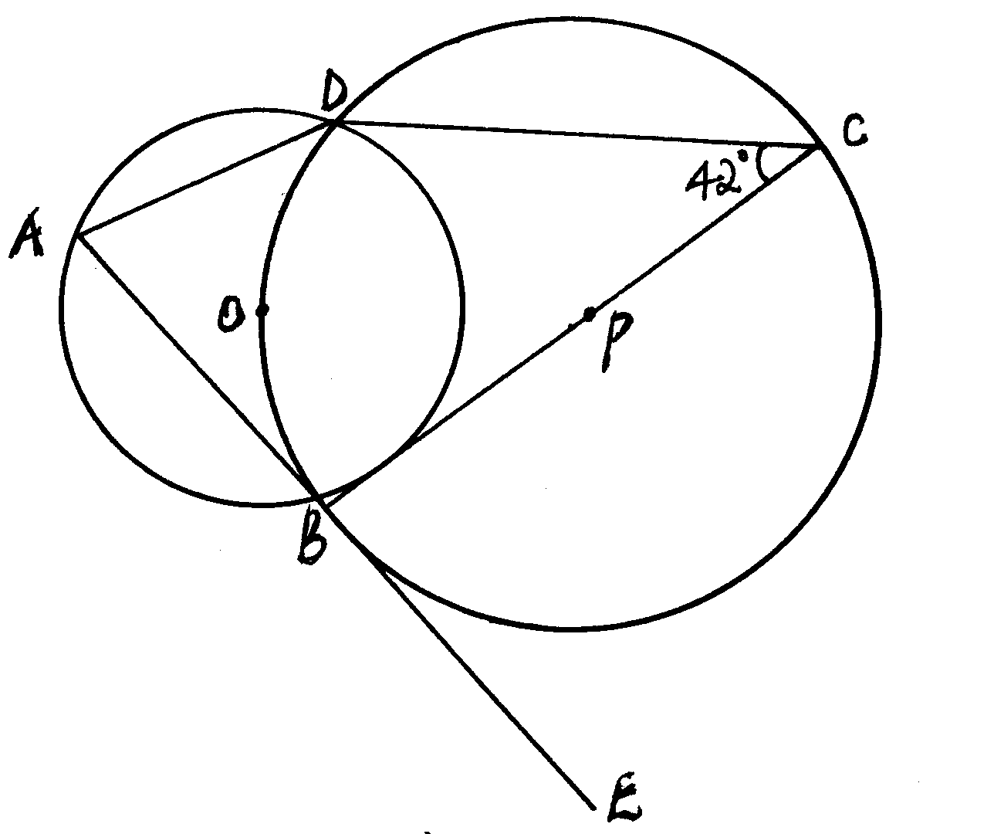
Giving reasons determine the size of:
(a) Angle CBD. (2mks)
(b) Angle ODB. (2mks)
(c) Angle BAD. (2mks)
(d) Angle ABD (2mks)
(e) Angle ODA. (2mks)
7. In the figure below, o is the centre of the circle. Express the angle w in terms of angles p and q. (2mks)
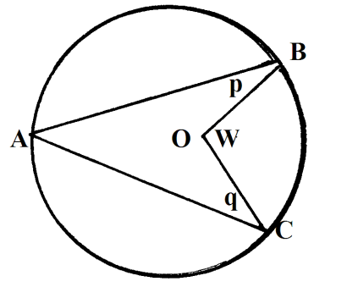
8. Two circles of radii 4cm and 6cm intersect as shown below. If angle XBY = 30º and
angle XAY = 97.2º.
Find the area of the shaded part.
X
Y
B
A
X
(Take = π 22 )
7

9. In the diagram, O is the centre of the circle and AD is parallel to BC. If angle ACB =50º
and angle ACD = 20º.
O
C
D
A
B
50º
20º

Calculate; (i) ∠OAB
(ii) ∠ADC
10. Two intersecting circles have centres S and R. Given that their two radii are 28cm and 35cm,
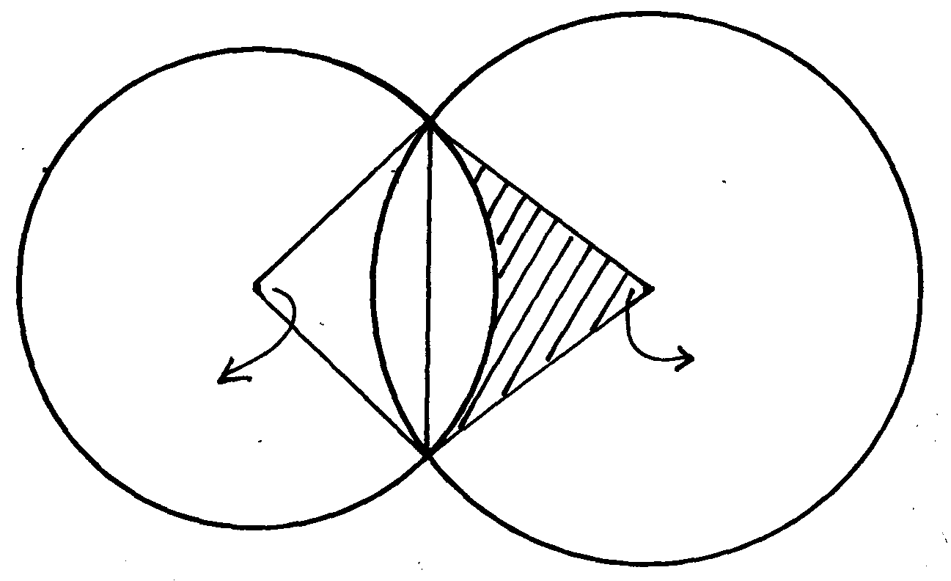
their common chord AB = 38cm and angles ASB = 85.46° and ARB = 65.76°,
85.46º
65.76º
S
28cm
35cm
R
A
B

Calculate the shaded area
11. In the figure below ABCD is a cyclic quadrilateral in which AD = DC and AB is parallel
to CD. Given that angle ABC = 80°, Find the size of:
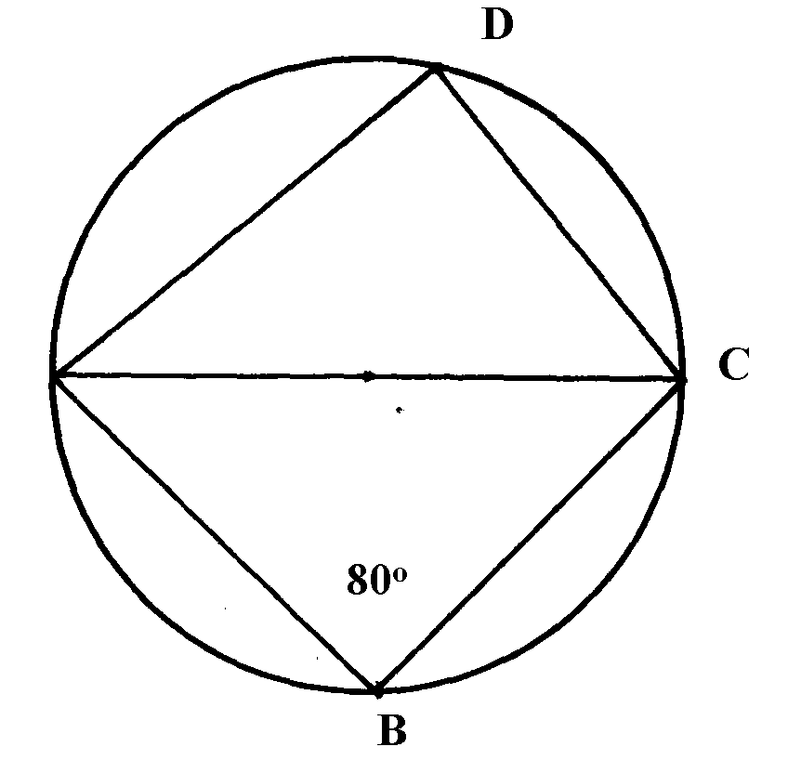
A
a) ∠DAC

b) ∠BAC

c) ∠BCD

12. Line QR = 6.5cm is given below:-(Do not use a protractor for this question)
(a) Draw triangle PQR such that p lies above line QR, ∠ PQR = 30º and PQ = 7cm
Q
R

(b) By accurate construction on the diagram above, show the locus of a point which lies
within the triangle such that:-
(i) T is more than 2.5cm from line PQ
and
(ii) T is not more than 4.5cm from Q
Shade the region in which T lies

(c) Lines QP and QR are produced to K and M respectively
(i) Show by construction on the diagram above, the locus of a point C which is
equidistant from each of the lines PK, PR and RM
(ii) With centre C and an appropriate radius, draw a circle to touch each of the lines
PK, PR and RM only once
Measure the radius
What name is given to the circle drawn in (c) (ii) with respect to triangle QPR
13. The figure below shows a circle centre O and a cyclic quadrilateral ABCD. AC = CD, angle
ACD is 80º and BOD is a straight line. Giving reasons for your answer, find the size of :-
C
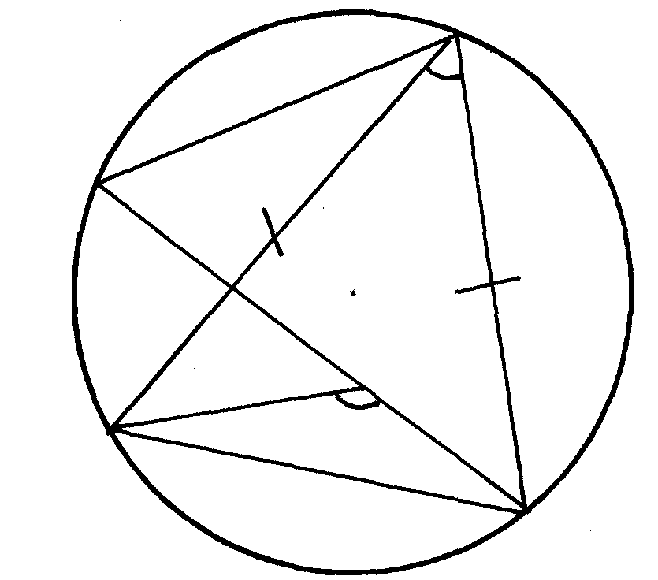
80º
B
X

A
O

(i) Angle ACB
D
(ii) Angle AOD
(iii) Angle CAB
(iv) Angle ABC
(v) Angle AXB
14. The figure below shows two circles of equal radius of 9 cm with centres A and B.
Angle CAD = 80º
B
D
C
A
•
•

a) Calculate the area of:-
i) The sector CAD. ii) The triangle CAD. iii) The shaded region.

15. In the diagram below, ∠QOT is a diameter. ∠QTP = 48º, ∠TQR = 46º and ∠SRT = 37º
R
Q
T
P
46º
O
37º
U
S
48º

Calculate, giving reasons in each case:-
(a) ∠RST
(b) ∠SUT
(c) ∠ROT
(d) ∠PST
(e) Reflex ∠SOP

16. The diagram below shows a circle with a chord PQ= 3.4cm and angle PRQ=40º.
Calculate the area of the shaded segment.
O
Q
P
R
40º
3.4cm

17. The figure below shows circle ABCD. The line EDF is a tangent to the circle at D.
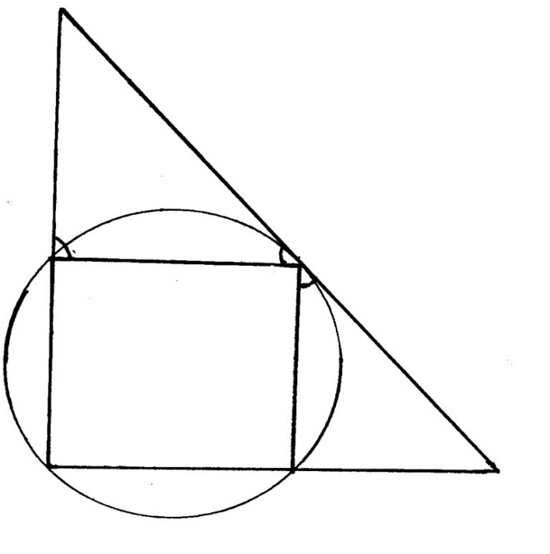
∠ADF = 70º ∠FAD = 65º and ∠CDE = 35º
F

65º
A
D
70º

35º

B
C
E

Find the values of the following angles, stating your reasons in each case
(a) ∠ABC
(b) ∠BCD
(c) ∠DCE
(d) ∠ACD

18. In the figure below BD is the diameter of the circle and O is the centre.
E

E
O
B
D
33º

Find the size of
(a) ∠ADC
48º
(b) ∠ AEB
C

